Introduction
- Software testing is the process of finding defects in a software
- The goal is to release quality software to the customer/client

Manual Testing
- Performing the testing without using any tools is known as Manual testing
- Here a tester/person will do the testing

Steps:

- Re-testing
- Testing same testcase again after a bug is fixed

- Regression Testing
- Software working according to client requirement or not?
- Checking existing functionality after changes to ensure nothing is broken
- New change/fix can impact other areas
- To make sure old features still work correctly

Automation Testing
- Performing the testing with the help of tools is known as Automation Testing
Steps:
- Testcases converted in Test script using Automation Tools
- Provide steps/Testcase to tool > tool can understand them and perform the actions on AUT
- We have to give instructions/Testcase/steps in certain language (Java) to the tools so that it can understand and perform the task
- Depending on tool we have the use language (Java, python, JS)
- Tool will perform actions automatically on the AUT

How can we overcome challenges while performing Re-testing and Regression testing while performing using Automation testing
- Repeat same test steps using Different set of Data
- Maintain Data in some source
- Write automation script (all steps)
- Automation script will read each and every input and same steps will be repeated by the tool

Manually this will take lot of time

Regression Testing Challenges
- Once we executed the 10 testcases and 2 had bugs then we will test the 8 passed testcases using Automation tool and 2 fixed testcases in manual way
- In next regression cycle we will pass the 2 testcases automation testing

We can provide Instructions to the Automation tools using Language (Java)

What is Selenium
- Collection of multiple Library (tool)
- Selenium is web-based automation tool/library

Types of Application
- Web application – Selenium
- Desktop Application
- Mobile Application

- Selenium is web-based automation tool/library
- Selenium was originally developed by Jason Huggins in 2004 Thoughtworks company
- Selenium is open source
- Selenium free
- Selenium is collection of multiple components (IDE, WebDriver, Grid)

Advantages
- Open-source tool & free
- Multiple OS
- Supports Multiple Browsers
- Supports multiple language (Java, python, C#, Ruby, JS, etc…)
- Integrate third party tools in to selenium

Disadvantages/ Limitations
- Cannot support windows-based application (Autoit, Sikuli, Robot API)
- Reporting not supported (TestNG, Extent reports)
- Cannot support excel files (Apache POI)
- Graphs, captua
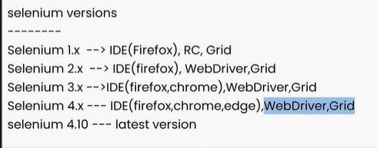

Java

What is Java?
- Object Oriented Programming Language

Types of Programming Language
- Structured – C, Python
- Object based – VB, VBScript, Python
- Object Oriented – C++, Java, C#, Python

OOPs
- Class
- Object
- Polymorphism
- Inheritance
- Abstraction
- Encapsulation

Features
- Platform independent
- Case sensitive

3 components
- JDK – Java Development kit
- JRE – Java run time environment
- JVM – Java virtual machine

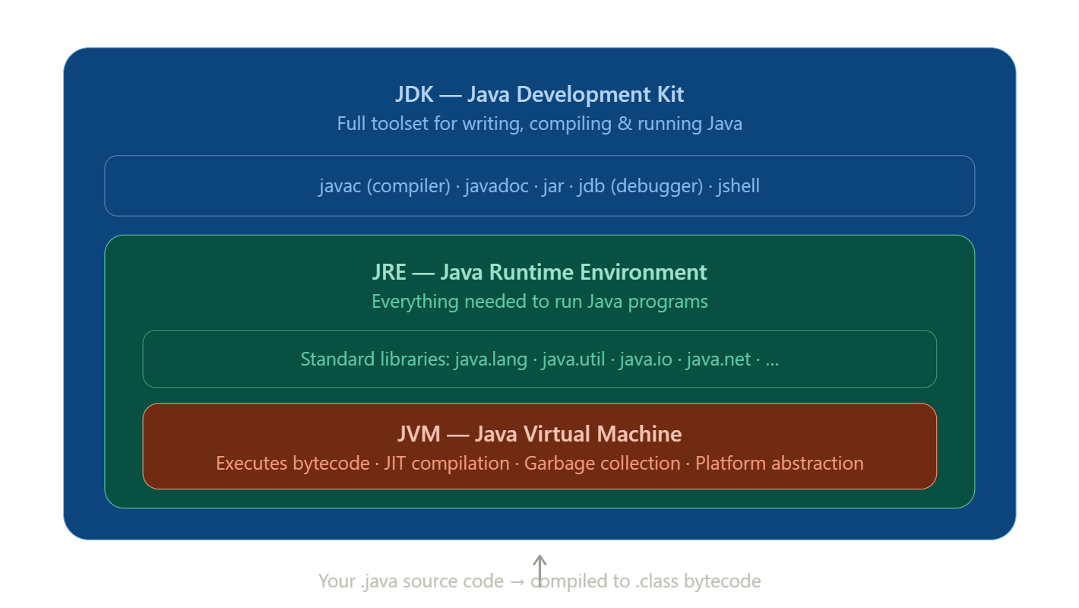

The key takeaway is the containment relationship: JVM ⊂ JRE ⊂ JDK.
- As an end user who just wants to run a Java app, you install the JRE.
- As a developer writing Java code, you install the JDK (which already includes the JRE inside it).
- The JVM is never installed separately — it comes bundled within whichever of the above you install.

Core Java
Advanced Java

Environment Setup
- JDK/Java
- IDE (Eclipse)

